Assignment 2

- Implement basic validation within the BookList component to prevent progression to the next step unless a book has been selected by the user
import { useState } from "react";
import "./App.css";

function Q1() {
const [, setBooks] = useState([]);
const [hasError, setHasError] = useState(false);

const handleFormSubmit = (event) => {
event.preventDefault();
const selectedBooks = [];

for (let element of event.target.elements) {
if (element.checked && element.type === "checkbox") {
selectedBooks.push(element.value);
}
}

if (!selectedBooks.length) {
setHasError(true);
return;
}

setBooks(selectedBooks);
console.log(selectedBooks);
};

return (
<>
<div>
<h1>
Choose from a wide variety of book available in our store
</h1>
{hasError && (
<div className="error">
<p>Please select at least one book.</p>
</div>
)}

<form onSubmit={handleFormSubmit}>
<table>
<tbody>
<tr>
<td>
<input
type="checkbox"
value="Zero to one -- Peter Thiel"
/>
</td>
<td>
<label>Zero to one -- Peter Thiel</label>
</td>
</tr>
<tr>
<td>
<input
type="checkbox"
value="The Monk who sold his ferrari -- Robin Sharma"
/>
</td>
<td>
<label>
The Monk who sold his ferrari -- Robin
Sharma
</label>
</td>
</tr>
<tr>
<td>
<input
type="checkbox"
value="The Alchemist -- Paulo Coelho"
/>
</td>
<td>
<label>The Alchemist -- Paulo Coelho</label>
</td>
</tr>
<tr>
<td>
<input
type="checkbox"
value="The Power of Now -- Eckhart Tolle"
/>
</td>
<td>
<label>
The Power of Now -- Eckhart Tolle
</label>
</td>
</tr>
<tr>
<td>
<input
type="checkbox"
value="Wings of fire -- APJ Abdul Kalam"
/>
</td>
<td>
<label>
Wings of fire -- APJ Abdul Kalam
</label>
</td>
</tr>
<tr>
<td>
<input type="submit" value="Submit" />
</td>
</tr>
</tbody>
</table>
</form>
</div>
</>
);
}

export default Q1;

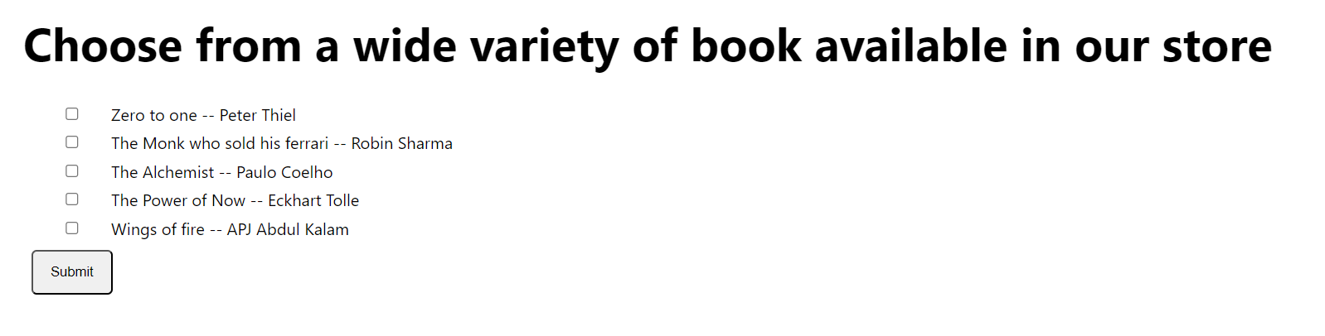
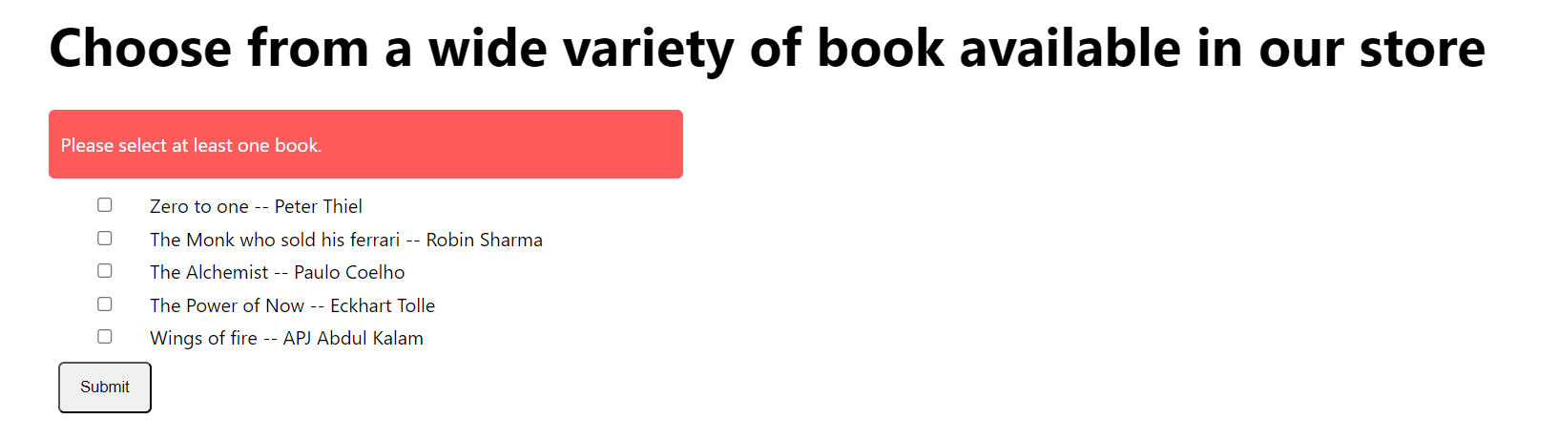

- Make the form like below in React with decrement timer
import { useEffect, useState } from "react";
import "./App.css";

const Timer = () => {
const [time, setTime] = useState(900);

useEffect(() => {
let timer = setInterval(() => {
setTime((time) => {
if (time === 0) {
clearInterval(timer);
setTime(900);
alert("Time is up!");
return 0;
} else return time - 1;
});
}, 1000);
}, []);

return (
<div className="bg">
<p>
<strong>Time Left:</strong>{" "}
{`${Math.floor(time / 60)}`.padStart(2, 0)} minutes{" "}
{`${time % 60}`.padStart(2, 0)} seconds before confirming order
</p>
</div>
);
};

export default function Q2() {
const handleSubmit = () => {
alert("Your order has been placed successfully!");
};
return (
<>
<h1>Enter your Shipping Information</h1>
<Timer />
<form>
<table>
<tbody>
<tr>
<input type="text" placeholder="Full Name" />
</tr>
<tr>
<input type="text" placeholder="Contact Number" />
</tr>
<tr>
<input type="text" placeholder="Shipping Address" />
</tr>
<tr>
<button onClick={handleSubmit}>Submit</button>
</tr>
</tbody>
</table>
</form>
</>
);
}

